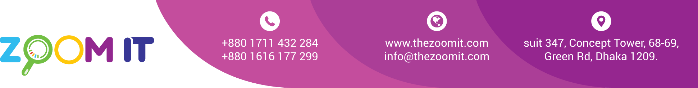

**Bill**

|  |  |
| --- | --- |
| Date | 14/09/2022 |
| INV. NO. | 10083 |

|  |  |
| --- | --- |
| Name | **ITS Holydays Ltd** |
| Address | House-150, Block-E, Road-10, Banani, Dhaka. |

|  |  |  |  |
| --- | --- | --- | --- |
| **Sl.**  **No.** | **Description** | **task** | **Value in Taka** |
| 1 | SEO  Web development  Last Month Due  **Amazing** | Monthly  Partial | 15,000  20,000  8,000 |
|  | | Total | 43,000 |
| Paid |  |
| Due |  |

BANK Details

Ac Name: ZOOM DIGITAL AC NO: 2228119002279

Prime bank Racecourse Branch

Signature